Testing LR=0.001, Dropout=0.2
Epoch 1 Loss: 31.3178 | Val Acc: 76.00
Epoch 2 Loss: 20.1771 | Val Acc: 80.00
Epoch 3 Loss: 12.8159 | Val Acc: 76.00
Epoch 4 Loss: 4.7565 | Val Acc: 82.00
Epoch 5 Loss: 2.0019 | Val Acc: 81.00
Epoch 6 Loss: 0.9736 | Val Acc: 80.00
Early stopping triggered

Testing LR=0.001, Dropout=0.3
Epoch 1 Loss: 33.0451 | Val Acc: 73.00
Epoch 2 Loss: 21.4247 | Val Acc: 76.00
Epoch 3 Loss: 11.8676 | Val Acc: 78.00
Epoch 4 Loss: 5.1413 | Val Acc: 79.00
Epoch 5 Loss: 1.9037 | Val Acc: 77.00
Epoch 6 Loss: 0.9701 | Val Acc: 78.00
Early stopping triggered

Testing LR=0.001, Dropout=0.4
Epoch 1 Loss: 32.6320 | Val Acc: 74.00
Epoch 2 Loss: 20.2542 | Val Acc: 76.00
Epoch 3 Loss: 13.5849 | Val Acc: 81.00
Epoch 4 Loss: 6.1524 | Val Acc: 82.00
Epoch 5 Loss: 3.8079 | Val Acc: 84.00
Epoch 6 Loss: 1.8548 | Val Acc: 83.00
Epoch 7 Loss: 0.7734 | Val Acc: 82.00
Early stopping triggered

Testing LR=0.001, Dropout=0.5
Epoch 1 Loss: 32.3744 | Val Acc: 69.00
Epoch 2 Loss: 22.3632 | Val Acc: 73.00
Epoch 3 Loss: 14.2640 | Val Acc: 77.00
Epoch 4 Loss: 8.3699 | Val Acc: 77.00
Epoch 5 Loss: 5.4869 | Val Acc: 75.00
Early stopping triggered

Testing LR=0.0005, Dropout=0.2
Epoch 1 Loss: 32.3591 | Val Acc: 68.00
Epoch 2 Loss: 23.8960 | Val Acc: 74.00
Epoch 3 Loss: 18.0690 | Val Acc: 79.00
Epoch 4 Loss: 12.5851 | Val Acc: 81.00
Epoch 5 Loss: 9.5320 | Val Acc: 81.00
Epoch 6 Loss: 6.9050 | Val Acc: 81.00
Early stopping triggered

Testing LR=0.0005, Dropout=0.3
Epoch 1 Loss: 32.5539 | Val Acc: 70.00
Epoch 2 Loss: 24.5876 | Val Acc: 76.00
Epoch 3 Loss: 18.9051 | Val Acc: 78.00
Epoch 4 Loss: 12.6714 | Val Acc: 79.00
Epoch 5 Loss: 9.5796 | Val Acc: 80.00
Epoch 6 Loss: 6.5884 | Val Acc: 79.00
Epoch 7 Loss: 4.0549 | Val Acc: 78.00
Early stopping triggered

Testing LR=0.0005, Dropout=0.4
Epoch 1 Loss: 33.0610 | Val Acc: 67.00
Epoch 2 Loss: 24.6277 | Val Acc: 73.00
Epoch 3 Loss: 19.8175 | Val Acc: 75.00
Epoch 4 Loss: 14.6239 | Val Acc: 79.00
Epoch 5 Loss: 11.6762 | Val Acc: 78.00
Epoch 6 Loss: 8.4671 | Val Acc: 81.00
Epoch 7 Loss: 4.7354 | Val Acc: 80.00
Epoch 8 Loss: 3.3773 | Val Acc: 82.00
Epoch 9 Loss: 2.0056 | Val Acc: 82.00
Epoch 10 Loss: 1.2062 | Val Acc: 83.00
Epoch 11 Loss: 0.9772 | Val Acc: 82.00
Epoch 12 Loss: 0.9240 | Val Acc: 83.00
Early stopping triggered

Testing LR=0.0005, Dropout=0.5
Epoch 1 Loss: 33.2255 | Val Acc: 69.00
Epoch 2 Loss: 25.5325 | Val Acc: 76.00
Epoch 3 Loss: 19.7976 | Val Acc: 77.00
Epoch 4 Loss: 14.7718 | Val Acc: 75.00
Epoch 5 Loss: 11.9463 | Val Acc: 77.00
Early stopping triggered

Testing LR=0.0001, Dropout=0.2
Epoch 1 Loss: 35.3389 | Val Acc: 49.00
Epoch 2 Loss: 32.0142 | Val Acc: 57.00
Epoch 3 Loss: 29.8811 | Val Acc: 65.00
Epoch 4 Loss: 28.0661 | Val Acc: 65.00
Epoch 5 Loss: 26.7655 | Val Acc: 64.00
Early stopping triggered

Testing LR=0.0001, Dropout=0.3
Epoch 1 Loss: 36.0414 | Val Acc: 59.00
Epoch 2 Loss: 33.0399 | Val Acc: 70.00
Epoch 3 Loss: 30.1129 | Val Acc: 73.00
Epoch 4 Loss: 28.9278 | Val Acc: 70.00
Epoch 5 Loss: 28.0580 | Val Acc: 71.00
Early stopping triggered

Testing LR=0.0001, Dropout=0.4
Epoch 1 Loss: 36.0337 | Val Acc: 61.00
Epoch 2 Loss: 33.4302 | Val Acc: 62.00
Epoch 3 Loss: 31.4762 | Val Acc: 69.00
Epoch 4 Loss: 30.2280 | Val Acc: 69.00
Epoch 5 Loss: 29.2849 | Val Acc: 73.00
Epoch 6 Loss: 27.9395 | Val Acc: 71.00
Epoch 7 Loss: 26.9884 | Val Acc: 74.00
Epoch 8 Loss: 26.4608 | Val Acc: 73.00
Epoch 9 Loss: 25.9101 | Val Acc: 73.00
Early stopping triggered

Testing LR=0.0001, Dropout=0.5
Epoch 1 Loss: 37.0559 | Val Acc: 65.00
Epoch 2 Loss: 33.9659 | Val Acc: 67.00
Epoch 3 Loss: 32.6860 | Val Acc: 67.00
Epoch 4 Loss: 29.0769 | Val Acc: 65.00
Early stopping triggered

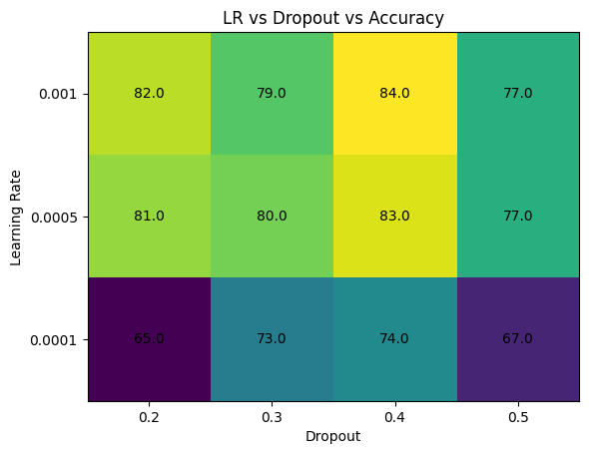

Best Config: (0.001, 0.4)
Test Accuracy: 77.0

===== Running BERT =====
Warning: You are sending unauthenticated requests to the HF Hub. Please set a HF_TOKEN to enable higher rate limits and faster downloads.
Loading weights: 100%
199/199 [00:00<00:00, 1070.99it/s]
BertForSequenceClassification LOAD REPORT from: bert-base-uncased
Key | Status |
-------------------------------------------+------------+-
cls.predictions.bias | UNEXPECTED |
cls.predictions.transform.LayerNorm.weight | UNEXPECTED |
cls.predictions.transform.LayerNorm.bias | UNEXPECTED |
cls.predictions.transform.dense.bias | UNEXPECTED |
cls.predictions.transform.dense.weight | UNEXPECTED |
cls.seq_relationship.bias | UNEXPECTED |
cls.seq_relationship.weight | UNEXPECTED |
classifier.weight | MISSING |
classifier.bias | MISSING |

Notes:
- UNEXPECTED: can be ignored when loading from different task/architecture; not ok if you expect identical arch.
- MISSING: those params were newly initialized because missing from the checkpoint. Consider training on your downstream task.
BERT Epoch 1 Val Acc: 91.00
BERT Epoch 2 Val Acc: 92.00
BERT Epoch 3 Val Acc: 93.00
BERT Test Accuracy: 94.0

